**1. INTRODUCTION**

This project involves developing a real-time attendance tracking system using face recognition technology. The project objective is to deliver an automated attendance system that eliminates manual processes, ensuring seamless, accurate, and efficient attendance tracking in educational institutions.

Face recognition technology allows the system to identify students through live video feeds, where each student's facial features are processed into unique face encodings. These encodings are then matched in real-time against stored records, and attendance is automatically updated in the Firebase database. This project is an attempt to leverage AI technology to enhance the efficiency of attendance management, providing a hands-free solution that saves time for both educators and students.

To ensure the system operates securely and efficiently, we have implemented secure authentication, asynchronous updates for scalability, and cloud storage to handle student data and images. These features allow for quick and reliable updates, making the system suitable for educational institutions of any size.

Future improvements to the system will focus on enhancing recognition accuracy and preventing misuse, such as attendance marking through digital or static photos, thereby ensuring that the system remains both secure and reliable.

**1.1 PROBLEM STATEMENT:**

This project aims to develop a **real-time attendance tracking system** using **face recognition technology** to automate attendance in educational institutions. The system identifies students through live video feeds, processes face encodings, and updates attendance in the **Firebase database**. It ensures **secure authentication**, **scalability through asynchronous updates**, and utilizes **cloud storage** for managing student data. Future enhancements will focus on improving **recognition accuracy** and preventing misuse via digital or static photos.

**1.2 OBJECTIVES:**

The objective of this project is to develop a **real-time attendance tracking system** using **face recognition technology** for educational institutions. To build such a system, the project incorporates AI-based face recognition, cloud storage, and secure authentication. The system is integrated with **Firebase** for real-time updates and scalability.

Some of the major objectives of this project are:

i. **Admin login/Student registration**  
ii. **Face recognition through live video feed**  
iii. **Real-time attendance updates**  
iv. **Asynchronous updates for scalability**  
v. **Cloud storage for student data and images**

**1.3 SCOPE:**

This **real-time attendance tracking system** using **face recognition technology** can be implemented in any educational institution, from local schools to large universities. The system operates 24/7, ensuring attendance can be managed efficiently across multiple classes and departments. By utilizing live video feeds and cloud storage, it provides a reliable and scalable solution for maintaining accurate student attendance records.

Institutions that adopt this system can prevent attendance fraud and enjoy the benefits of automated record-keeping, eliminating the need for manual roll calls. Since the system is integrated with cloud services and accessible through web interfaces, it is easily available and can be accessed from any connected device at any time.

**2. RELATED WORK**

**2.1 EXISTING SYSTEM/ Papers:**

The current attendance systems in educational institutions typically rely on manual

processes or outdated methods such as roll calls, paper registers, or RFID cards. These

methods present several limitations:

1. **Manual roll calls**: Teachers must manually take attendance, which is time-consuming and prone to errors.
2. **Inaccurate records**: Human errors in marking attendance can lead to discrepancies, making it difficult to maintain accurate records.
3. **Proxy attendance**: Students can easily mark attendance for their peers using manual methods or RFID cards, leading to fraudulent attendance.
4. **Lack of real-time tracking**: Existing systems do not allow for real-time updates or easy monitoring of student attendance.
5. **Limited scalability**: Traditional systems are not suitable for large institutions with numerous classes and students.
6. **Data management issues**: Paper-based systems and even some digital systems struggle with efficient data storage and accessibility, leading to delayed reporting and analysis.

**3. SYSTEM DESIGN**





Fig: E-R Diagram

System analysis is a crucial step in the development of the **real-time attendance tracking system** utilizing **face recognition technology**. This process involves gathering and interpreting relevant data, diagnosing existing problems with traditional attendance methods, and leveraging this information to propose effective improvements.

The analysis begins with a comprehensive examination of current attendance systems in educational institutions. Through extensive communication between system users—such as educators, students, and administrative staff—and system developers, we identify the pain points associated with manual attendance tracking. These pain points include inaccuracies, time consumption, and the potential for proxy attendance.

In the system analysis phase, the proposed solution is viewed holistically. Inputs, such as live video feeds from cameras positioned in classrooms, are identified as key components for capturing students' faces in real time. The system will process these face encodings using advanced algorithms, ensuring a robust method for student identification. By updating attendance records in the **Firebase database**, we aim to facilitate immediate access to accurate attendance data.

This analysis leads to the development of several critical features of the system:

* **Secure Authentication**: Ensures that only authorized personnel can access attendance data and system functionalities, protecting student information and maintaining data integrity.
* **Asynchronous Updates for Scalability**: This design choice allows the system to handle multiple classrooms and high volumes of students without lag or delay, ensuring a smooth user experience.
* **Cloud Storage**: Utilizing cloud storage solutions to manage student data and images offers flexibility, security, and easy accessibility, essential for institutions with varied needs.

## 

## 3.1 PROPOSED SYSTEM

## In the proposed real-time attendance tracking system using face recognition technology, students will no longer need to physically check in for attendance. Instead, the system will automatically identify students through live video feeds, capturing their face encodings in real time. This innovative approach eliminates the need for manual roll calls and enhances the overall efficiency of attendance management.

## The system will have a user-friendly interface that allows educators and administrators to easily monitor and manage attendance records. Teachers can view real-time attendance updates and generate reports without any hassle. Furthermore, the system will feature secure authentication, ensuring that only authorized personnel can access sensitive attendance data.

## To support the management of student data, the system will utilize Firebase for seamless updates and storage. Educators will have the option to set up moderators or assistants who can help manage attendance and oversee the system's operations.

## 3.2 SYSTEM DESIGN

**1. Camera Input and Live Video Feed**

* **Camera Initialization:** The system starts with a live video feed from a camera (using OpenCV’s cv2.VideoCapture). This live video captures real-time images of individuals (students) in the frame. The camera feed is continuously processed to detect faces and check for a match with the known database of student faces.
* **Frame Processing:** Each frame from the video is resized to optimize performance (i.e., reducing the frame size to 1/4 of its original size). This resizing helps process the frames quickly, as smaller frames require less computational power while still retaining sufficient detail for face recognition.

**2. Face Detection and Recognition**

* **Face Detection:** OpenCV and the face_recognition library are used to detect faces in the video frames. The system employs the face_locations() function, which identifies the coordinates of faces within the video frames.
* **Face Encoding Generation:** The face_encodings() function converts each detected face into a unique face encoding, a numerical representation of the facial features. This encoding acts as a unique identifier, somewhat similar to a fingerprint.
* **Face Matching:** The system compares these live encodings against a preloaded list of known face encodings stored in a serialized file (EncodeFile.p). The face_recognition.compare_faces() function checks for similarities between the live face encodings and the stored encodings. If a match is found (i.e., the difference between the encodings is below a defined threshold, such as 0.5), the student’s identity is confirmed.
* **Bounding Box:** Once a match is found, a bounding box is drawn around the recognized face using cvzone.cornerRect(), indicating that the system has successfully identified the student.
* **Attendance Marking:** After identification, the student’s attendance is marked. The system checks if the student's last attendance time was recorded more than 30 seconds ago (to avoid marking attendance multiple times within a short period). If the student has not been marked recently, the attendance is updated in Firebase asynchronously.

**3. Data Management**

* **Firebase Real-Time Database:** The system uses Firebase to store and manage student data, including their names, student IDs, majors, attendance records, and other details. For each recognized student, the system retrieves their information from the Firebase real-time database.
  + **Student Information Retrieval:** Each student's record is stored under a unique identifier (usually the student ID) in the Firebase database. The system accesses this record to fetch details such as the student’s total attendance, major, year of study, standing, and last attendance time.
  + **Attendance Update:** After recognizing a student, the system increments the student’s total_attendance count by 1 and updates the last_attendance_time with the current date and time. This update is done in real-time using Firebase's SDK, ensuring that the attendance data is always up to date and securely stored.
  + **Secure Handling via Firebase Admin SDK:** All interactions with the Firebase database are managed via the Firebase Admin SDK, ensuring that communication between the application and the Firebase backend is secure and authenticated.

**4. Cloud Storage**

* **Firebase Cloud Storage Integration:** Student images are stored in Firebase Cloud Storage. This storage system is used for saving and retrieving student images to provide a visual reference for the recognized student in the user interface.
  + **Image Upload:** When a new student is added to the system via the admin interface, their image is uploaded to Firebase Cloud Storage. The image is resized (typically to 216x216 pixels) and saved under a unique filename (the student ID) in a dedicated folder (Images/) in the Firebase Cloud Storage bucket.
  + **Image Retrieval:** During the face recognition process, when a student is recognized, the system retrieves the student's image from Firebase Storage

using the student ID. The image is downloaded from the cloud, decoded into a

usable format (using OpenCV and NumPy), and displayed in the system's graphical interface.



Fig: Block Diagram

**4. METHODOLOGY**

The proposed system follows a structured methodology, combining face recognition technology with cloud-based data storage for real-time attendance tracking. The methodology is divided into various stages, from data collection and registration to attendance processing and report generation. Below is a step-by-step breakdown of the methodology:

**4.1 Data Collection and Registration**

* **Admin-Driven Registration:**
  + The system starts with the admin registering new students. The admin collects essential details such as the student’s name, class, contact information, and uploads their image to the system.
  + The image is resized and stored in Firebase Cloud Storage. Each student is assigned a unique identifier (student ID), which links their personal details, face encoding, and attendance record in Firebase.
* **Face Encoding for Registered Users:**
  + Once the image is uploaded, the system uses the face_recognition library to generate a unique face encoding for each student. This encoding is a numerical representation of the student's facial features and serves as the basis for face recognition.
  + The face encodings are stored securely in the Firebase database, where they are linked to the corresponding student’s ID.

**4.2 User Login and Access**

* **Student Login:**
  + Students must log in using their unique username and password. The login system ensures secure access to attendance tracking features.
  + After logging in, students can view their attendance records and launch the camera for attendance marking. Access to the system is controlled through Firebase Authentication, ensuring that only registered users can interact with the system.
* **Admin Login:**
  + Admins have a separate login interface, allowing them to manage student data, monitor attendance records, and oversee system operations. Admins can add, update, or delete student information via this interface.

**4.3 Real-Time Attendance Marking**

* **Live Video Feed for Face Recognition:**
  + After login, the student initiates the attendance process by launching the camera. The system captures the live video feed using OpenCV (cv2.VideoCapture).
  + Each frame from the video feed is processed for face detection and recognition using the face_recognition library. The face detection process (face_locations()) identifies the position of the face within the frame, while face_encodings() extracts the facial features for matching.
* **Face Matching and Identification:**
  + The system compares the real-time face encoding from the live feed with the pre-stored encodings in the Firebase database using the face_recognition.compare_faces() function. If a match is found, the student is identified and their attendance is processed.
  + Visual confirmation (bounding boxes around faces) is provided through OpenCV and cvzone.cornerRect() to indicate a successful face match.

**4.4 Attendance Processing**

* **Attendance Record Update:**
  + Once the student is recognized, the system checks for the last recorded attendance to avoid redundant entries. If the last attendance was marked more than 30 seconds ago, a new attendance record is added.
  + The student’s attendance status is updated in Firebase in real-time. This asynchronous update ensures scalability and minimal delays.
  + Each student’s total attendance count is incremented, and the corresponding date and time of the attendance are logged.

**4.5 Data Management and Cloud Storage**

* **Firebase Database and Authentication:**
  + Firebase serves as the backbone for managing student data, attendance records, and authentication. Each student’s personal information, face encoding, and attendance history are stored in the Firebase real-time database, which ensures that data can be accessed and updated quickly.
  + Firebase Authentication secures the login process for both students and admins, preventing unauthorized access to the system.
* **Cloud Storage for Student Images:**
  + Student images, uploaded during registration, are stored in Firebase Cloud Storage. These images are retrieved during face recognition to match the live feed against stored data.
  + The images are stored in a secure bucket, and file naming conventions (e.g., studentID.jpg) ensure easy access when needed for face recognition or display.

**4.6 Viewing Attendance Records**

* **Student Access to Attendance Reports:**
  + After logging in, students can view their attendance records. The system retrieves the attendance history from Firebase and presents it in a user-friendly format.
  + Students can track their daily attendance, including dates and times when they were present or absent, allowing them to monitor their performance and attendance trends.

**4.7 Admin Monitoring and Control**

* **Admin Dashboard:**
  + The admin has a dedicated dashboard that allows them to oversee the entire system. Admins can:
    - Approve new student registrations and unblock users.
    - View overall attendance reports and metrics.
    - Add or update student information.
    - Access real-time attendance records for each student, ensuring efficient management of attendance data.

**5. SYSTEM REQUIREMENTS**

The development and deployment of the real-time attendance tracking system using face recognition technology requires both hardware and software components to ensure smooth functionality and efficiency. The following system requirements are essential for implementing this project:

**5.1 Hardware Requirements:**

1. **Camera:**

A high-resolution camera is required for capturing clear live video feeds of students. This can be a webcam, smartphone camera, or an integrated laptop camera.

1. **Server or Cloud Infrastructure:**

A reliable server or cloud infrastructure is needed to host the web-based application, manage user authentication, and store attendance data.

1. **Computing Devices:**

Laptops, desktops, or smartphones with sufficient processing power to handle real-time face recognition algorithms and video feed processing.

1. **Internet Connectivity:**

A stable internet connection is essential for real-time data syncing between the client devices and the Firebase database.

**5.2 Software Requirements:**

1. **Operating System:**
   * Client-side: Windows, macOS, Linux, or any mobile OS (iOS, Android) compatible with the web application.
   * Server-side: Windows Server, Linux-based systems, or any cloud-based OS supporting web hosting and database management.
2. **Programming Languages:**
   * Frontend: HTML, CSS, JavaScript (for creating a user-friendly interface for student login, launching the camera, and accessing attendance records).
   * Backend: Python or Node.js for handling the server-side logic, communication with the Firebase database, and processing the face recognition data.
3. **Face Recognition Libraries:**

OpenCV, Dlib, or any suitable machine learning framework for implementing the face recognition algorithm.

1. **Database Management System:**

Firebase is utilized for storing student data, attendance records, and face encodings. Firebase provides real-time updates and cloud storage, allowing scalability and easy access.

1. **Authentication Framework:**

Secure authentication frameworks (such as Firebase Authentication) are implemented to ensure that only authorized users, including administrators and students, can access the system.

1. **Web Framework:**

Flask, Django (for Python) or Express (for Node.js) to develop the web application and integrate frontend, backend, and database functionalities.

1. **Browser Compatibility:**

The web application must be compatible with modern web browsers (Google Chrome, Mozilla Firefox, Safari) to ensure smooth access from various devices.

1. **Cloud Storage:**

Firebase Cloud Storage is used to store and manage student images and related data for the face recognition system.

By fulfilling these system requirements, the real-time attendance tracking system will function efficiently, providing a reliable and scalable solution for educational institutions.

**6. RESULTS**

1. Landing Page

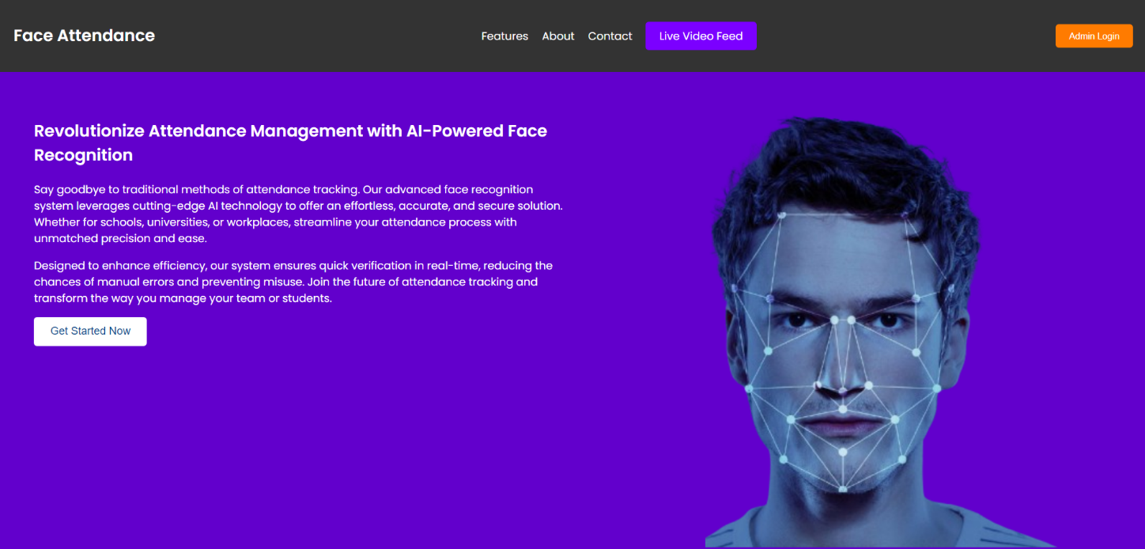

2. Features

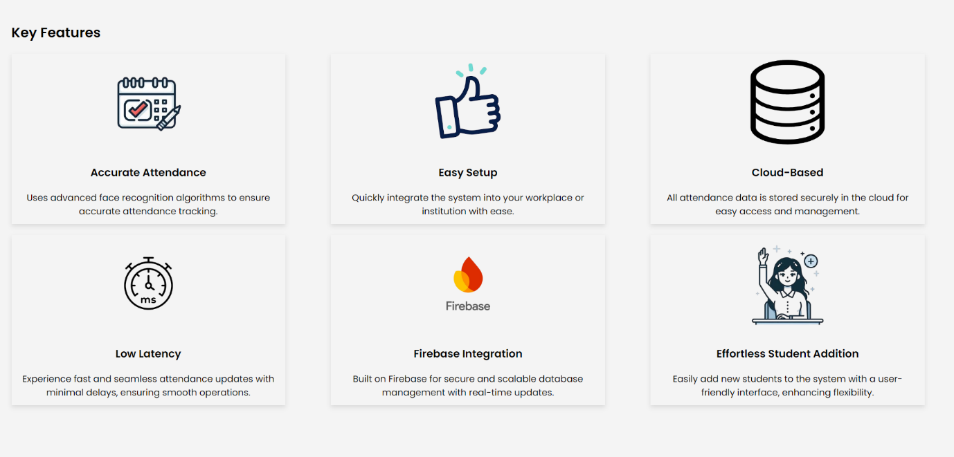

3. About Us

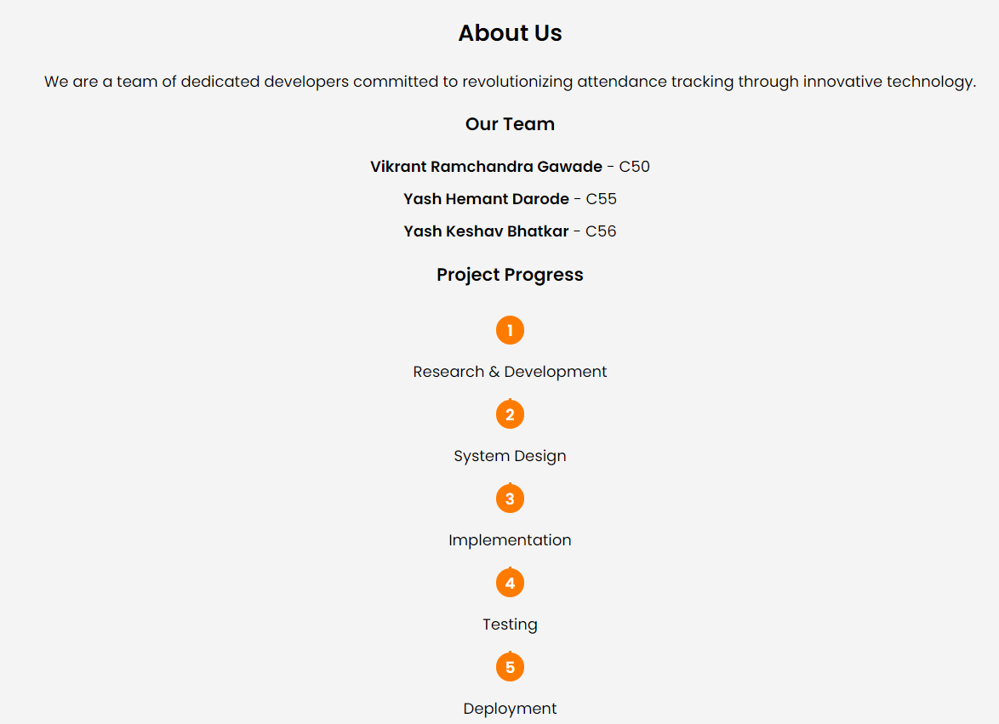

4.Contact Us

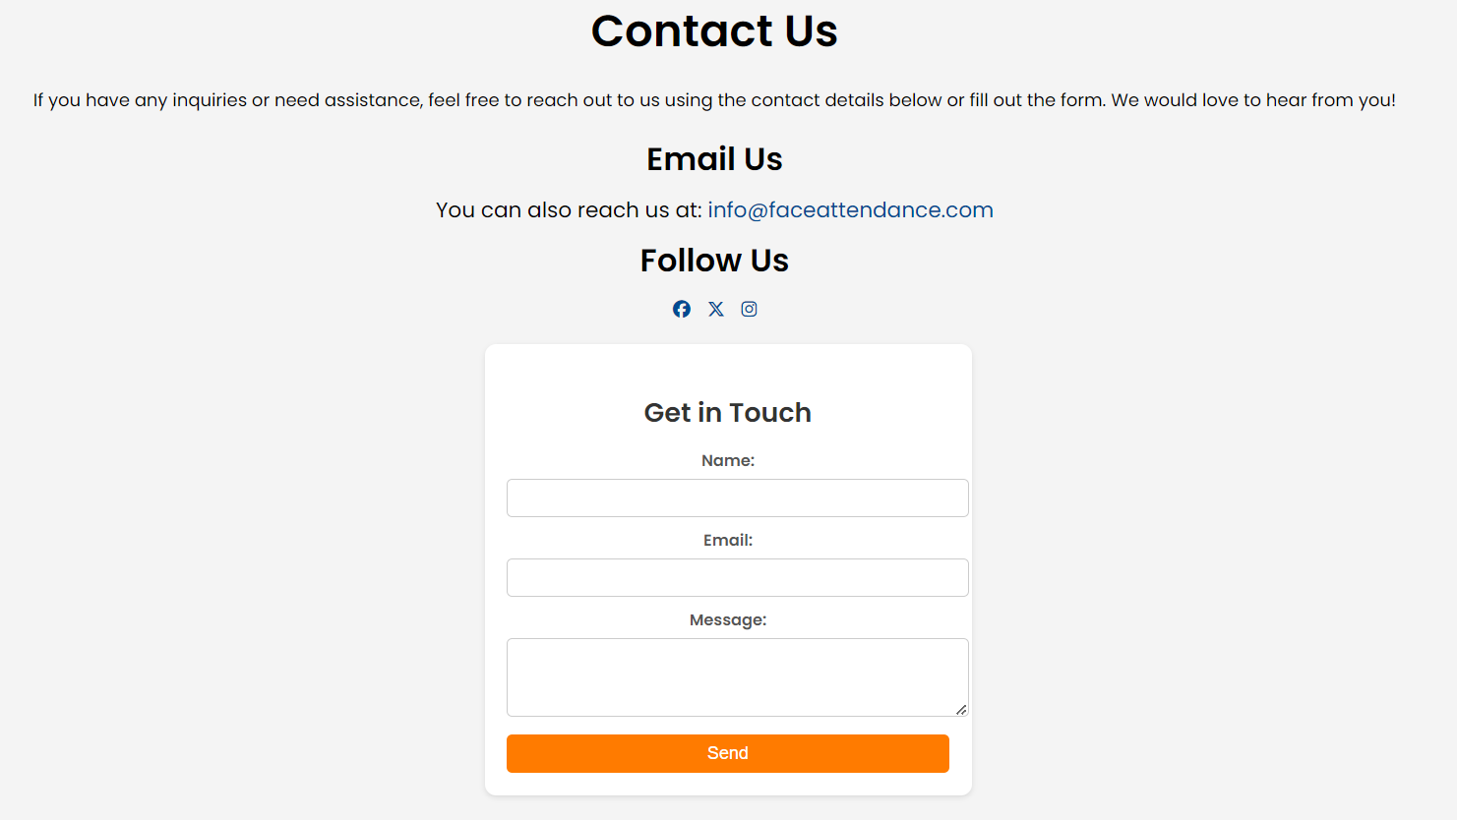

5. Launch Video Feed

This feature activates the live video feed to scan students' faces. If a student is recognized and exists in the database, their attendance is marked instantly.

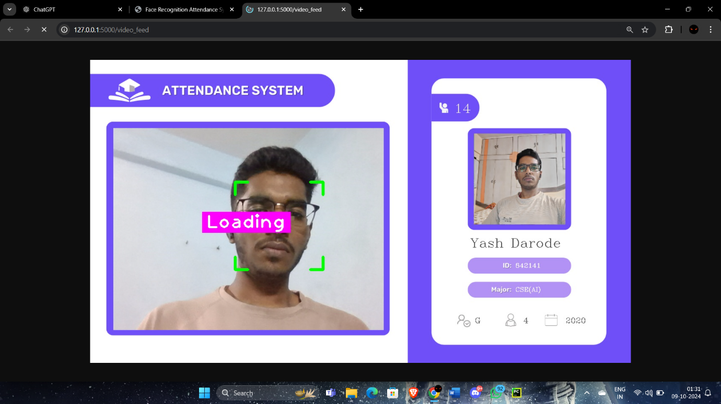

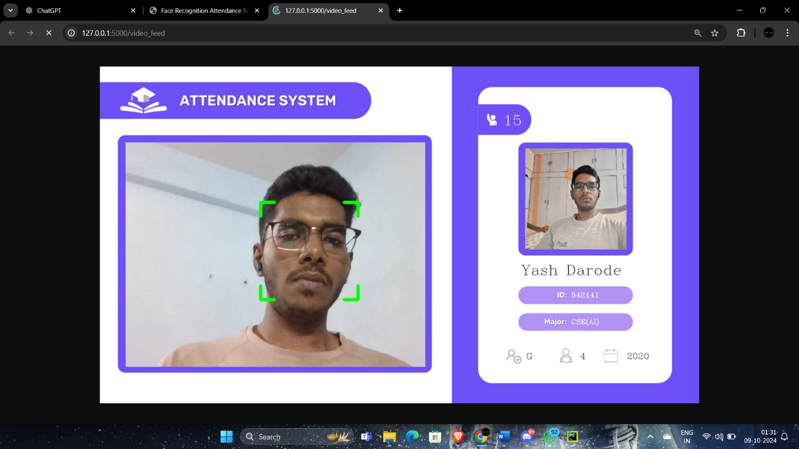

6. Admin Login

The Admin Login portal allows authorized users to manage the system. Admins can view, update student data, and add new students. Once a new student is added, their information is encoded and added to the system within a few minutes.

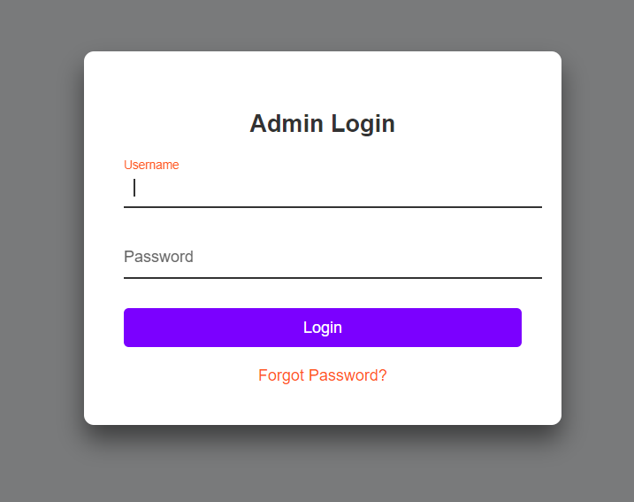

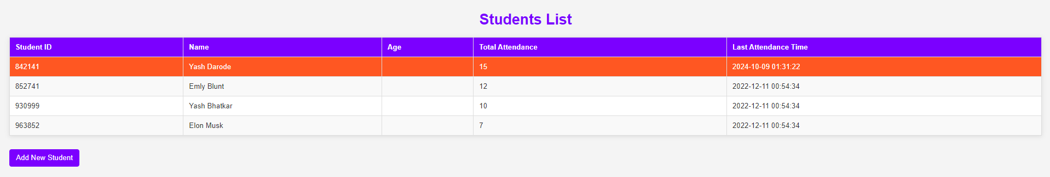

7. Add Student

Admins can add new students by inputting their details through the system's interface. After adding, the student’s face encoding is processed, and their information will be fully added to the Firebase database after a few minutes, ready for attendance tracking.

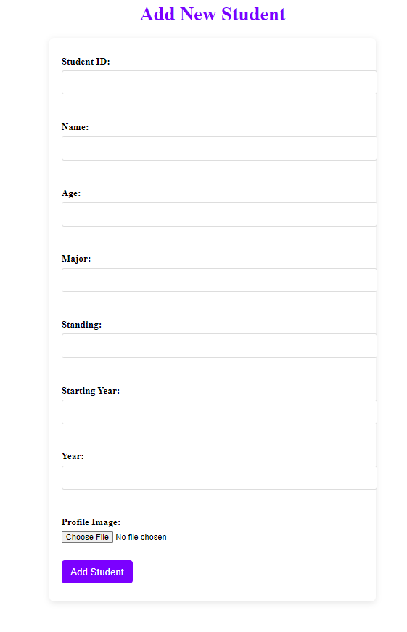

**DEMO:**

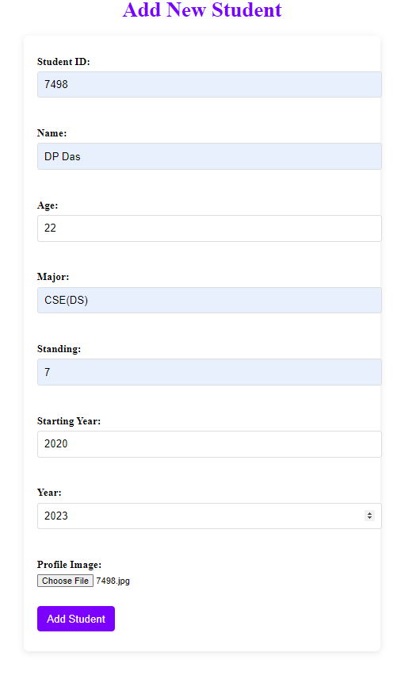

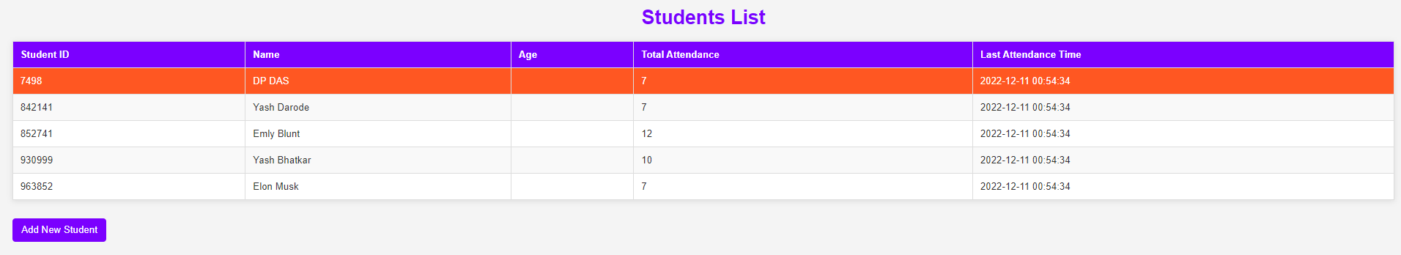

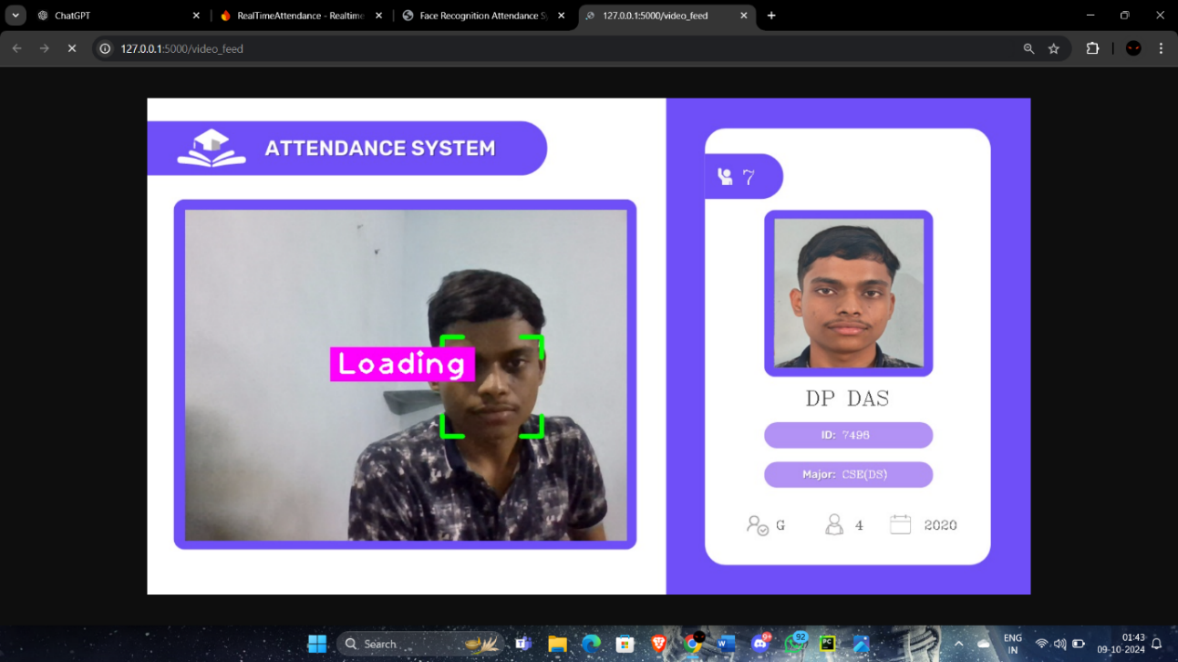

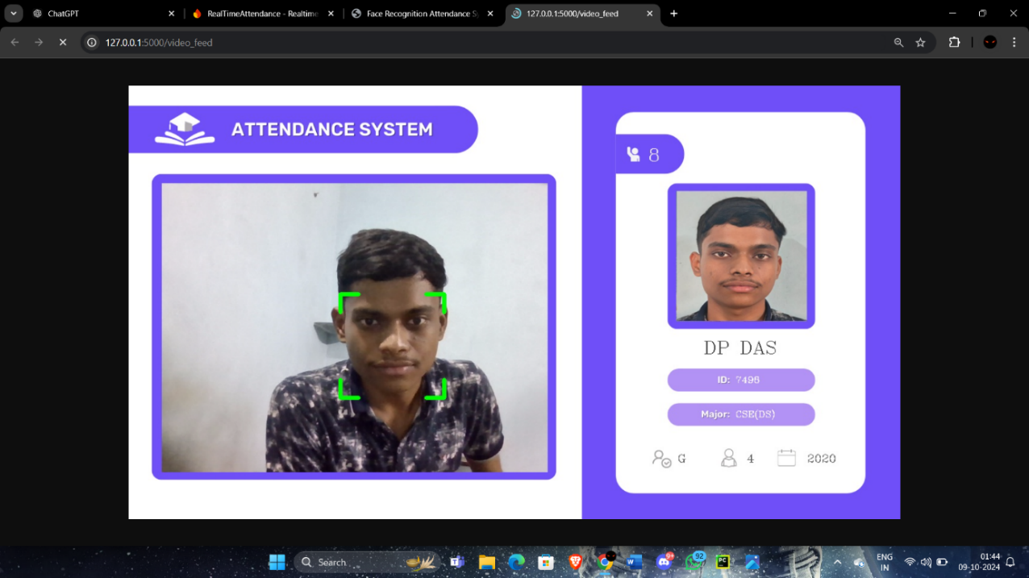

**CONCLUSION**

The Smart Attendance System using face recognition technology represents a significant leap forward in automating and streamlining the attendance process in educational institutions. By leveraging real-time video feeds and facial recognition, the system eliminates the inefficiencies and inaccuracies of traditional methods such as manual roll calls and RFID cards. The integration with Firebase ensures secure storage of student data, enabling administrators to manage attendance records efficiently. Key features like low-latency processing, secure authentication, asynchronous updates, and cloud-based storage make this system scalable and well-suited to handle large volumes of student data.

The Admin Login feature allows authorized personnel to manage student data, with an easy-to-use interface for adding new students to the database. Once added, the student’s information is encoded and updated in the system after a few minutes, ensuring seamless integration without delays. The system’s design prioritizes both accuracy and usability, making it a powerful tool for institutions of various sizes. Additionally, the system includes a Launch Video Feed option that actively scans student faces and instantly marks attendance for those registered in the database, significantly improving the speed and accuracy of attendance tracking.

**Future Scope**

While the current system achieves its intended goals, there are several avenues for enhancing its functionality and expanding its reach:

1. Improved Face Recognition Accuracy: As the system relies on face recognition, future developments could focus on improving the algorithm to recognize faces under various lighting conditions, different angles, and in crowded environments. Incorporating deep learning models such as Convolutional Neural Networks (CNNs) can enhance the system’s ability to differentiate between similar facial features and reduce false positives or negatives.
2. Prevention of Proxy Attendance: Future iterations could include advanced techniques such as liveness detection, which can distinguish between a live person and a photo or video, thereby preventing fraudulent attendance marking through static or digital photos.
3. Mobile Integration: Developing a mobile app for both Android and iOS platforms would increase accessibility. Students and faculty members could check attendance records, view reports, and receive notifications on their mobile devices, making the system more convenient.
4. Real-Time Analytics and Dashboards: Integrating a dashboard feature for administrators and teachers would allow real-time tracking and monitoring of student attendance. This would enable instant insights into attendance patterns, trends, and anomalies, providing actionable data to improve class engagement.
5. Cross-Institutional Scalability: With future enhancements, the system could be extended to accommodate multiple institutions, allowing administrators to manage attendance across different campuses or locations. This could be particularly useful for large universities, corporate training centers, or any organization with distributed operations.
6. Biometric Integration: Expanding the system to include multi-factor authentication such as fingerprint or iris scanning could further enhance security and prevent unauthorized access. This would provide an added layer of protection for the system’s data and ensure higher levels of accuracy.
7. Cloud Scalability: As more institutions adopt the system, the demand for storage and processing power will increase. By further leveraging cloud technologies like auto-scaling, the system could automatically adjust resources to handle peak usage times, ensuring consistent performance.
8. Remote and Hybrid Learning Integration: In response to the growing demand for remote and hybrid learning environments, the system could be adapted to support virtual attendance tracking through webcam integration for students attending online classes. This would make the system flexible enough to handle both physical and virtual attendance needs.
9. Automated Reporting and Alerts: Introducing an automated reporting feature could help faculty members by providing attendance summaries at regular intervals. Additionally, alert systems could notify students, parents, or administrators when a student’s attendance falls below a certain threshold, improving accountability.

**References**

[1] Smart Attendance System using OPENCV based on Facial Recognition. Shruti Bharuka #1 Sudhir Bussa #2 Ananya Mani #3 Sakshi Kaushik #4 Department of Electronics and Telecommunication, Bharati Vidyapeeth (Deemed to be) University, College of Engineering, Dhankawadi, Pune, India. 411043.

[2] Facial Recognition Based Attendance System Using Opencv.Ms. K. Vyshnavi 1, Suhel Shaik 2, Mylavarapu Santosh Kumar 3, M.S.V Praveen4, Swetha Potti5 1,2,3,4,5 Department of Computer Science and Engineering, Nadimpalli Satyanarayana Raju Institute of Technology, Visakhapatnam-531173.

[3] Employee Attendance Management System Using OpenCV. A.Siva Narayana1, T. Ramanjineyulu2, K. Raj Kumar3, 1,2,3 Department of Electronics and Communication Engineering, Madanapalle Institute of Technology & Science Kadiri Road, Madanapalle 517325 Chithoor Dist, Andhrapradesh

[4] An Automated Approach for Classroom Attendance Using OpenCV. A Bhuvan Dattu1, C Govind Teja2, HM Omprakash3, Vinod Kumar4, Dr. Phanindra Reddy K5 Department of Artificial Intelligence and Machine Learning, Ballari Institute of Technology and Management, India

[5] SMART ATTENDANCE MANAGEMENT SYSTEM (SAMS): ATTENDANCE TRACKING PROCESS IN EDUCATIONAL INSTITUTION. Darshana Band*1, Garima Agrawal#2, Harshada Deo#3, Vaishnavi Dhengekar#4, Rushikesh Dadanje#5 Prof. Yugandhara Thakare#6 12345 Students of Final Year, Sipna College Engineering and Technology, Amravati, Maharashtra, India. 6 Assistant Professor, Department of Computer Science and Engineering, Sipna College of Engineering and Technology, Amravati, Maharashtra, India.

[6] Smart Campus: Smart Attendance Management System Using Face Recognition Abhishek Singh1, Anushka Kalra2, Reva Teotia3, Sanskriti Mamgain4. 1Student, Artificial Intelligence and Machine Learning, Inderprastha Engineering College. 2,3,4Student, Computer Science and Engineering, Inderprastha Engineering College.